

**Children and Young Peoples Health & Wellbeing Newsletter – Spring Term 2023 – Addition 1**

[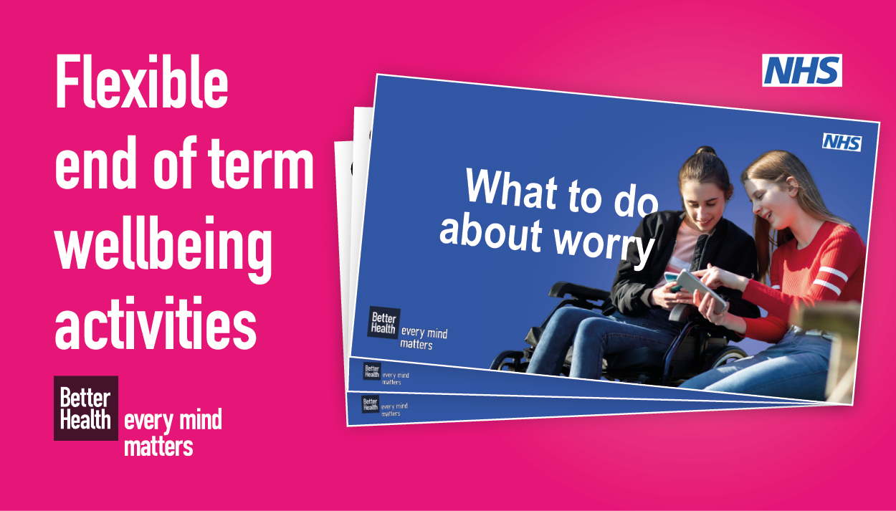](http://links.e.phepartnerships.co.uk/els/v2/bxXvsrYaGyFP/b244RnZXZDFWelZyUUt1NnQrL1hLTVo5ZXBVWjdTT241eUR6ZVdmbjViaFV1SjFGUUFCRkY4U3pvRlJxSVE0VGtzRlFGczFaekQvTWJLNS9rOWFHeE1BUjREeGE4N0ZXSVlReWVnTzFCUDA9S0/)

Among all the fun and festivities, Christmas can be an overwhelming time for young people who may struggle with their mental wellbeing and the pressure to feel happy.1  
  
Linking to the **PSHE and Relationships Education curriculums**, our **[What to do about worry](http://links.e.phepartnerships.co.uk/els/v2/j9L2cAkqgyhP/b244RnZXZDFWelZyUUt1NnQrL1hLTVo5ZXBVWjdTT241eUR6ZVdmbjViaFV1SjFGUUFCRkY4U3pvRlJxSVE0VGtzRlFGczFaekQvTWJLNS9rOWFHeE1BUjREeGE4N0ZXSVlReWVnTzFCUDA9S0/" \t "_blank)** resource can help Year 6 pupils identify worry and provide them with actions they can take if they feel worried in the lead-up to the festive holidays and beyond.

This resource contains **interactive activities** featuring an **engaging video** and a **‘relaxation station'**. You can use this resource flexibly, either as a whole lesson plan or as wraparound content towards the end of term.  
  
Head to the School Zone to download this free resource and explore our other curriculum linked resources, including **[Building connections](http://links.e.phepartnerships.co.uk/els/v2/rNWkB2mvKVJ0/b244RnZXZDFWelZyUUt1NnQrL1hLTVo5ZXBVWjdTT241eUR6ZVdmbjViaFV1SjFGUUFCRkY4U3pvRlJxSVE0VGtzRlFGczFaekQvTWJLNS9rOWFHeE1BUjREeGE4N0ZXSVlReWVnTzFCUDA9S0/" \t "_blank)** which can be used to help young people connect when they return to school in January.

[](http://links.e.phepartnerships.co.uk/els/v2/~N7YB0WbjzJq/b244RnZXZDFWelZyUUt1NnQrL1hLTVo5ZXBVWjdTT241eUR6ZVdmbjViaFV1SjFGUUFCRkY4U3pvRlJxSVE0VGtzRlFGczFaekQvTWJLNS9rOWFHeE1BUjREeGE4N0ZXSVlReWVnTzFCUDA9S0/)

[](http://links.e.phepartnerships.co.uk/els/v2/amedhPZ4ybHx/b244RnZXZDFWelZyUUt1NnQrL1hLTVo5ZXBVWjdTT241eUR6ZVdmbjViaFV1SjFGUUFCRkY4U3pvRlJxSVE0VGtzRlFGczFaekQvTWJLNS9rOWFHeE1BUjREeGE4N0ZXSVlReWVnTzFCUDA9S0/)

|  |
| --- |
| **Set aside time for your own wellbeing** |
| Setting aside time for your own wellbeing can be challenging during busy term times but with the **free Every Mind Matters Mind Plan**, you can find simple ways to care for your own wellbeing at a time that suits you.  To download your plan, simply head to the **[Every Mind Matters website](http://links.e.phepartnerships.co.uk/els/v2/X67zB9wmKEHa/b244RnZXZDFWelZyUUt1NnQrL1hLTVo5ZXBVWjdTT241eUR6ZVdmbjViaFV1SjFGUUFCRkY4U3pvRlJxSVE0VGtzRlFGczFaekQvTWJLNS9rOWFHeE1BUjREeGE4N0ZXSVlReWVnTzFCUDA9S0/" \t "_blank)** or use an Alexa device by saying **“Alexa, start mind plan”**.  Small things can make a big difference. Take time this Christmas to be kind to your mind. |

[](http://links.e.phepartnerships.co.uk/els/v2/6LP6MV_xeDFK/b244RnZXZDFWelZyUUt1NnQrL1hLTVo5ZXBVWjdTT241eUR6ZVdmbjViaFV1SjFGUUFCRkY4U3pvRlJxSVE0VGtzRlFGczFaekQvTWJLNS9rOWFHeE1BUjREeGE4N0ZXSVlReWVnTzFCUDA9S0/)

[](https://brook.us4.list-manage.com/track/click?u=38b7f9ecb5927031865d12bd0&id=bbd52e9109&e=31f71979c5)

At Brook we believe all young people should learn about puberty in a timely and age-appropriate way. We also know it's important to make puberty education relevant to children's experiences so that they are prepared for the changes to their bodies, feelings and lives. That is why we have teamed up with [Lil-Lets](https://brook.us4.list-manage.com/track/click?u=38b7f9ecb5927031865d12bd0&id=a4d6374c74&e=31f71979c5) to deliver The Big Period Lesson Live on 1 March 2023 at 10am. The broadcast is free to access and aimed at young people in year 6&7.   
  
Led by expert Brook educators, the lesson will support your students to better understand their bodies, define what puberty and periods are, and know where to go for support. The first 50 schools to sign up will receive 100 Lil-Lets Teen Starter Packs to give to your students. ([See Ts&Cs](https://brook.us4.list-manage.com/track/click?u=38b7f9ecb5927031865d12bd0&id=a237da18d4&e=31f71979c5))   
  
Please register your class or assembly today and share with your contacts so that as many young people as possible can benefit from this important lesson.

|  |
| --- |
| [**SIGN UP NOW**](https://brook.us4.list-manage.com/track/click?u=38b7f9ecb5927031865d12bd0&id=1677ce702a&e=31f71979c5) |

**BROOK RESOURCES FOR YOUNG PEOPLE**

[](https://brook.us4.list-manage.com/track/click?u=38b7f9ecb5927031865d12bd0&id=10d6f28277&e=31f71979c5)

**Brook website**

Our website offers an unrivalled range of help, advice and resources designed specifically for young people. We have introduced a series of new pages about contraception including [t](https://brook.us4.list-manage.com/track/click?u=38b7f9ecb5927031865d12bd0&id=cbe18a2c87&e=31f71979c5)[here's a condom for everyone](https://brook.us4.list-manage.com/track/click?u=38b7f9ecb5927031865d12bd0&id=9b75024aa0&e=31f71979c5), [FAQs and mythbusters](https://brook.us4.list-manage.com/track/click?u=38b7f9ecb5927031865d12bd0&id=132ad96543&e=31f71979c5) and [talking to your partner about contraception](https://brook.us4.list-manage.com/track/click?u=38b7f9ecb5927031865d12bd0&id=980c722a7c&e=31f71979c5).

|  |
| --- |
| [**FIND OUT MORE**](https://brook.us4.list-manage.com/track/click?u=38b7f9ecb5927031865d12bd0&id=cacbbe1fd0&e=31f71979c5) |

**BROOK RESOURCES FOR PROFESSIONALS**

](https://brook.us4.list-manage.com/track/click?u=38b7f9ecb5927031865d12bd0&id=601b630589&e=31f71979c5)

**Brook Learn**

[Introduction to RSE (free)](https://brook.us4.list-manage.com/track/click?u=38b7f9ecb5927031865d12bd0&id=486558d3af&e=31f71979c5) is a must for anyone looking for a grounding in the core themes of sex and relationships education and wanting to develop an engaging curriculum, while our updated [CPD-accredited Traffic Light Tool training](https://brook.us4.list-manage.com/track/click?u=38b7f9ecb5927031865d12bd0&id=6b22362b46&e=31f71979c5) helps professionals to identify, understand and respond appropriately to sexual behaviours in young people.

|  |
| --- |
| [**ENROL NOW**](https://brook.us4.list-manage.com/track/click?u=38b7f9ecb5927031865d12bd0&id=6ae5f8d92e&e=31f71979c5) |

**TRAFFIC LIGHT TOOL TRAIN-THE-TRAINER**

|  |
| --- |
| Do you want to become a licenced trainer of Brook's Traffic Light Tool? We are running a full day online training on 26 January 2023. The day includes: introduction to sexual health, spotting the signs of inappropriate sexualised behaviour and full Traffic Light Tool Training. For more information about the training, including prices, please get in touch. |

|  |
| --- |
| [**CONTACT US**](mailto:training@brook.org.uk?subject=TLT%20Train%20the%20Trainer) |

](https://brook.us4.list-manage.com/track/click?u=38b7f9ecb5927031865d12bd0&id=d22ab6d482&e=31f71979c5)

**Professional Training**

Our training sessions offer guidance on a range of prominent topics that aim to support you to work with children and young people. Any of our courses can be adapted to fit the needs of your staff. Browse a selection of the most popular topics, or get in touch to discuss how Brook can help you.

|  |
| --- |
| [**SEND US AN ENQUIRY**](https://brook.us4.list-manage.com/track/click?u=38b7f9ecb5927031865d12bd0&id=996b2549e3&e=31f71979c5) |

**Upcoming dates**

RSPB's Big Schools' Birdwatch

**January 27, 2023 - January 29, 2023**

Big Schools’ Birdwatch is back for 2023, bigger and with even more resources than before. Join thousands of other schools to find out which birds visit your school grounds. Together, let’s make it count.

[Big Schools’ Birdwatch (rspb.org.uk)](https://www.rspb.org.uk/fun-and-learning/for-teachers/schools-birdwatch/)

[Big Schools Birdwatch - Teaching Resources - Twinkl](https://www.twinkl.co.uk/event/big-schools-birdwatch-2023#:~:text=January%2027%2C%202023%20%2D%20January%2029%2C%202023&text=The%20RSPB%27s%20Big%20Schools%27%20Birdwatch%20is%20a%20citizen%20science%20project,part%20of%20this%20important%20research.)

Veganuary is an annual campaign to encourage and support people from all over the world to [go vegan](https://www.veganfoodandliving.com/how-to-go-vegan/how-to-go-vegan-tips/) for January.

[Veganuary 2023: Everything you need to know about going vegan (veganfoodandliving.com)](https://www.veganfoodandliving.com/veganuary/veganuary-guide/)

**Chinese New Year 2023 is the year of the Rabbit**

Sunday 22nd January 2023

[Chinese New Year 2023 | Event Info | Teaching Resources (twinkl.co.uk)](https://www.twinkl.co.uk/event/chinese-new-year-taiwan-2023)

Children’s Mental Health Week 2023 will take place from **6-12 February 2023**. This year’s theme is **Let’s Connect.**

Our free resources for  [**primary age**](https://www.childrensmentalhealthweek.org.uk/schools/primary-age-activities/)  and [**secondary age**](https://www.childrensmentalhealthweek.org.uk/schools/secondary-age-activities/) children and young people will help you take part in the week. Activities in our resources are designed to encourage children (and adults) to consider how we can make meaningful connections that support our mental health.

[Primary age activities - Children's Mental Health Week (childrensmentalhealthweek.org.uk)](https://www.childrensmentalhealthweek.org.uk/schools/primary-age-activities/)

[2,509 Top "Childrens Mental Health Week 2023" Teaching Resources curated for (twinkl.co.uk)](https://www.twinkl.co.uk/search?q=childrens+mental+health+week+2023&c=244&r=parent)

**6th – 12th February 2023**

Schools’ Football Week is an ongoing ESFA initiative designed as an opportunity for schools, teams and clubs from across the country to embrace schools’ football and the wellbeing benefits it provides to pupils and players. It celebrates the importance of schools’ football, competitive or otherwise, to pupils across England and provides teachers and coaches with tools and a motivation to further discuss the benefits of schools’ football within their educational environment.

[Schools' Football Week – Brought to you by the English Schools' Football Association (schoolsfootballweek.co.uk)](https://schoolsfootballweek.co.uk/)

**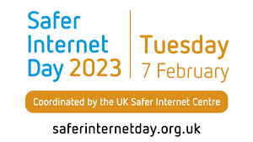**

**Safer Internet Day 2023** will take place on the 7thof February 2023, with celebrations and learning based around the theme ‘**Want to talk about it? Making space for conversations about life online**’.

Coordinated in the UK by the UK Safer Internet Centre, the celebration sees thousands of organisations get involved to promote the safe, responsible and positive use of digital technology for children and young people.

In the UK, we are celebrating by putting children and young people’s voices at the heart of the day and encouraging them to shape the online safety support that they receive. That is why we are asking parents, carers, teachers, government, policymakers, and the wider online safety industry to take time to listen to children and young people and make positive change together.

This year we are hoping to answer the following questions:

* What issues really matter to children and young people?
* What changes do they want to see?
* How can we all work together to advocate for them moving forward?

[Safer Internet Day 2023 - UK Safer Internet Centre](https://saferinternet.org.uk/safer-internet-day/safer-internet-day-2023)

[Teachers and school staff - UK Safer Internet Centre](https://saferinternet.org.uk/guide-and-resource/teachers-and-school-staff) – for resources.



World Book Day

2nd March, 2023

World Book Day is one of the highlights of our year at the National Literacy Trust! We love the annual celebration of authors, illustrators, books and the joy of reading.  Check out the [**2023 list of £1 World Book Day titles**](https://www.worldbookday.com/books/).

[World Book Day 2023 announcements - World Book Day](https://www.worldbookday.com/2022/09/world-book-day-2023-announcements/)



**Training Dates**

**PSHE Network – PRIMARY**

Wednesday 25th January, 2023 - 15:30 – 16:30

Thursday 11th May, 2023 - 15:30 – 16:30

[PSHE Network - PRIMARY Tickets, Multiple Dates | Eventbrite](https://www.eventbrite.co.uk/e/pshe-network-primary-tickets-396413622817)

**PSHE Network – SECONDARY**

Wednesday 1st February 2023 - 15:15 – 16:15

Thursday 18th May, 2023 - 15:15 – 16:15

[PSHE Network - SECONDARY Tickets, Multiple Dates | Eventbrite](https://www.eventbrite.co.uk/e/pshe-network-secondary-tickets-396423131257)

**Free Senior Mental Health Lead Training by Anna Freud Centre**

Book your **free place** on this CPD accredited training to gain tools to champion mental health across your school or FE college community. Places are fully funded by a Department for Education grant, worth £1,200.

This two-day training has been co-developed by expert clinicians and teachers ensuring a learning experience that is evidence-informed and practical. The training will equip you with the knowledge and skills to implement a tailored, whole-school or college approach to promote the mental health and wellbeing of your pupils and staff.

Places are available to book on our [online Spring 2023 training dates](https://gbr01.safelinks.protection.outlook.com/?url=https%3A%2F%2Fannafreud.msnd24.com%2Ftracking%2Flc%2F862fffca-d484-4024-8493-12d2e5212dde%2F2e393c73-9aa5-4543-8047-27b069451139%2F7c5da205-4419-41d9-ad9b-e7132a5b655f%2F&data=05%7C01%7Cgeorge.voulgaris%40nhs.net%7Cad0ccdd426a7436eff4a08dadf6202c7%7C37c354b285b047f5b22207b48d774ee3%7C0%7C0%7C638067909305363603%7CUnknown%7CTWFpbGZsb3d8eyJWIjoiMC4wLjAwMDAiLCJQIjoiV2luMzIiLCJBTiI6Ik1haWwiLCJXVCI6Mn0%3D%7C3000%7C%7C%7C&sdata=EBZCWYpxz7to0aGiTUYqM4W5wmHVWrnUhm5f%2FardNMs%3D&reserved=0), as well as on our [face-to-face training dates](https://gbr01.safelinks.protection.outlook.com/?url=https%3A%2F%2Fannafreud.msnd24.com%2Ftracking%2Flc%2F862fffca-d484-4024-8493-12d2e5212dde%2Fef4b7a34-c32f-462a-be2b-fa4bfe78557e%2F7c5da205-4419-41d9-ad9b-e7132a5b655f%2F&data=05%7C01%7Cgeorge.voulgaris%40nhs.net%7Cad0ccdd426a7436eff4a08dadf6202c7%7C37c354b285b047f5b22207b48d774ee3%7C0%7C0%7C638067909305363603%7CUnknown%7CTWFpbGZsb3d8eyJWIjoiMC4wLjAwMDAiLCJQIjoiV2luMzIiLCJBTiI6Ik1haWwiLCJXVCI6Mn0%3D%7C3000%7C%7C%7C&sdata=%2Be2jqbMLWrKDuO0NnsAxO5LLm0FW1%2F52Jmjdcy9XTV8%3D&reserved=0) in London.

We are additionally running a training starting in late January [exclusively for FE college staff](https://gbr01.safelinks.protection.outlook.com/?url=https%3A%2F%2Fannafreud.msnd24.com%2Ftracking%2Flc%2F862fffca-d484-4024-8493-12d2e5212dde%2Fd8de5ea9-46bc-487a-8839-e8aa53ff27db%2F7c5da205-4419-41d9-ad9b-e7132a5b655f%2F&data=05%7C01%7Cgeorge.voulgaris%40nhs.net%7Cad0ccdd426a7436eff4a08dadf6202c7%7C37c354b285b047f5b22207b48d774ee3%7C0%7C0%7C638067909305363603%7CUnknown%7CTWFpbGZsb3d8eyJWIjoiMC4wLjAwMDAiLCJQIjoiV2luMzIiLCJBTiI6Ik1haWwiLCJXVCI6Mn0%3D%7C3000%7C%7C%7C&sdata=dRh9iA6xQkhtf%2FN0YTElomIktC%2B%2FdcNWEUiPn6q993E%3D&reserved=0) so you have the opportunity to meet and learn with colleagues facing similar challenges and experiences.

**Talk Suicide Training**

**TAKE THE TRAINING. SAVE A LIFE. #TALKSUICIDE**

Anyone can suffer from suicidal thoughts but every one of us can make a difference.

A life is lost through suicide every two hours in the UK but suicidal thoughts and feelings affect thousands of us every single day.

The #TalkSuicide campaign has been created by the Humber and North Yorkshire Health and Care Partnership to reduce the stigma around talking about suicide by raising awareness of free suicide prevention training available from the Zero Suicide Alliance.

**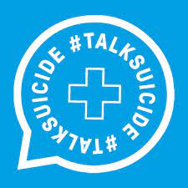**

* FREE 20 minute online suicide prevention training
* Learn how to spot suicide warning signs and have a conversation with someone you’re worried about
* [www.talksuicide.co.uk](http://www.talksuicide.co.uk)



**MECC e-learning**

* To understand public health and the factors that impact on a person’s health and wellbeing.
* It focuses on how asking questions and listening effectively.
* A ‘MECC interaction’ takes a matter of minutes and is not intended to add to existing busy workloads, rather it is structured to fit into and complement existing engagement approaches.
* NEL Training Academy being developed- will include holistic MECC.

[Making Every Contact Count - elearning for healthcare (e-lfh.org.uk)](https://www.e-lfh.org.uk/programmes/making-every-contact-count/)

